**2030 – DINESH K LOHAR**

**ASSIGNMENT 6**

**JAVASCRIPT ASSIGNMENT-2 (OBJECTS)**

**Q.1** JavaScript Objects

**A) Demonstrating different JavaScript Objects such as String, Regular Expression, Math, Date.**

**SOURCE CODE:-**

<!--Dinesh K Lohar 2030-->

<!--A)Demonstrating different JavaScript Objects such as String, Regular Expression, Math, Date.-->

<!DOCTYPE html>

<html>

<head>

<meta charset="utf-8">

<title>JavaScript Objects</title>

<style>

p {

font-size: 28px;

font-family: Cambria;

padding: 20px;

}

body {

background-image: url("bg2.jpg");

background-size: cover;

}

.button {

border: none;

color: white;

padding: 20px 32px;

text-align: center;

text-decoration: none;

display: inline-block;

font-size: 26px;

margin: 4px 2px;

transition-duration: 0.4s;

cursor: pointer;

}

.button1 {

background-color: white;

color: black;

border: 3px solid #080096;

}

.button1:hover {

background-color: #ffb300;

color: black;

}

</style>

<script type="text/javascript">

//String Object

function stringObj() {

var string1 = "Web Development";

var string2 = "Covid-19 Pandemic 2020 is a Curse.";

var string3 = "Dinesh K Lohar";

var pos = "2020";

var length = " * A Length of a String '" + string1 + "' : " + string1.length;

var position = " * The Position of a String '" + pos + "' in a String '" + string2 + "' : " + string2.indexOf(pos);

var upper = " * A Sring '" + string3 + "' in UpperCase : " + string3.toUpperCase();

var lower = " * A Sring '" + string3 + "' in LowerCase : " + string3.toLowerCase();

var char = " * A Sring '" + string3 + "' have a Character at Index 7 : " + string3.charAt(7);

document.getElementById("op").innerHTML = "The String object lets you work with a series of characters; it wraps Javascript's string primitive data type with a number of helper methods.<br /><br />" + length + "<br />" + position + "<br />" +

upper + "<br />" + lower + "<br />" + char;

}

//Regular Expression

function regxObj() {

var string = "Best of Luck for Exams, Do well.";

var pattern = /Luck/i;

var result = " * Searching 'Luck' in a String '" + string + "' : ";

var res = " ";

if (string.match(pattern) == "Luck") {

res = " Yes, 'Luck' is present in the String.";

} else {

res = " No, 'Luck' is not present in the String.";

}

document.getElementById("op").innerHTML = "A regular expression is an object that describes a pattern of characters.<br /><br />" + result + res;

}

//Math Object

function mathObj() {

var pi = " * Value of Pi : " + Math.PI;

var sin = " * Value of Sin(60) : " + Math.sin(60);

var cos = " * Value of Cos(80) : " + Math.cos(80);

var tan = " * Value of Tan(30) : " + Math.tan(30);

var ceil = " * The Ceiling Number of 12.5 : " + Math.ceil(12.5);

var floor = " * The Flooring Number of 36.5 : " + Math.floor(36.5);

var min = " * The Smallest Number in (41, 50, 25, 78) : " + Math.min(41, 50, 25, 78);

var max = " * The Largest Number in (41, 50, 25, 78) : " + Math.max(41, 50, 25, 78);

var power = " * Value of 2 to the Power 4 : " + Math.pow(2, 4);

var square = " * The Square Root of 150 : " + Math.sqrt(150);

var abs = " * The abs of -54 : " + Math.abs(-54);

var result = pi + "<br />" + sin + "<br />" + cos + "<br />" + tan + "<br />" + ceil + "<br />" + floor + "<br />" + min + "<br />" + max + "<br />" + power + "<br />" + square + "<br />" + abs;

document.getElementById("op").innerHTML = "A regular expression is an object that describes a pattern of characters.<br /><br />" + result;

}

//Date Object

function dateObj() {

var date = new Date();

var result = " * Current Date & Time is "+date;

document.getElementById("op").innerHTML = "The Date object is a datatype built into the JavaScript language. Date objects are created with the new Date( ) as shown below.<br /><br />"+result;

}

</script>

</head>

<body>

<center>

<h1>A) DEMONSTRATION OF SOME JAVASCRIPT OBJECTS</h1>

<br><br><br>

<button class="button button1" type="button" onclick="stringObj()">String Object</button>

<button class="button button1" type="button" onclick="regxObj()">RegEx Object</button>

<button class="button button1" type="button" onclick="mathObj()">Math Object</button>

<button class="button button1" type="button" onclick="dateObj()">Date Object</button>

<br><br>

</center>

<p id="op">JavaScript is designed on a simple object-based paradigm. An object is a collection of properties, and a property is an association between a name (or key) and a value. A property's value can be a function, in which case the property is known as a method. In addition to objects that are predefined in the browser, you can define your own objects. This chapter describes how to use objects, properties, functions, and methods, and how to create your own objects.</p>

</body>

</html>

**OUTPUT:-**

**Home Page**

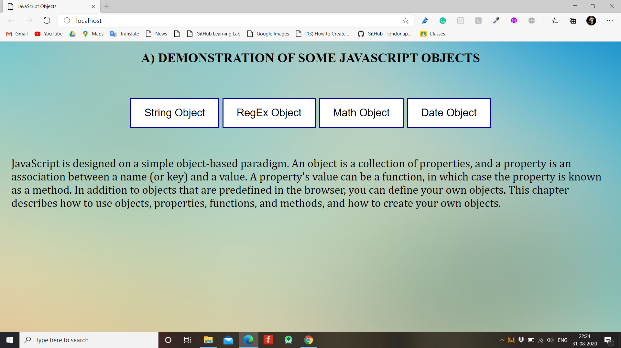

**String Object**

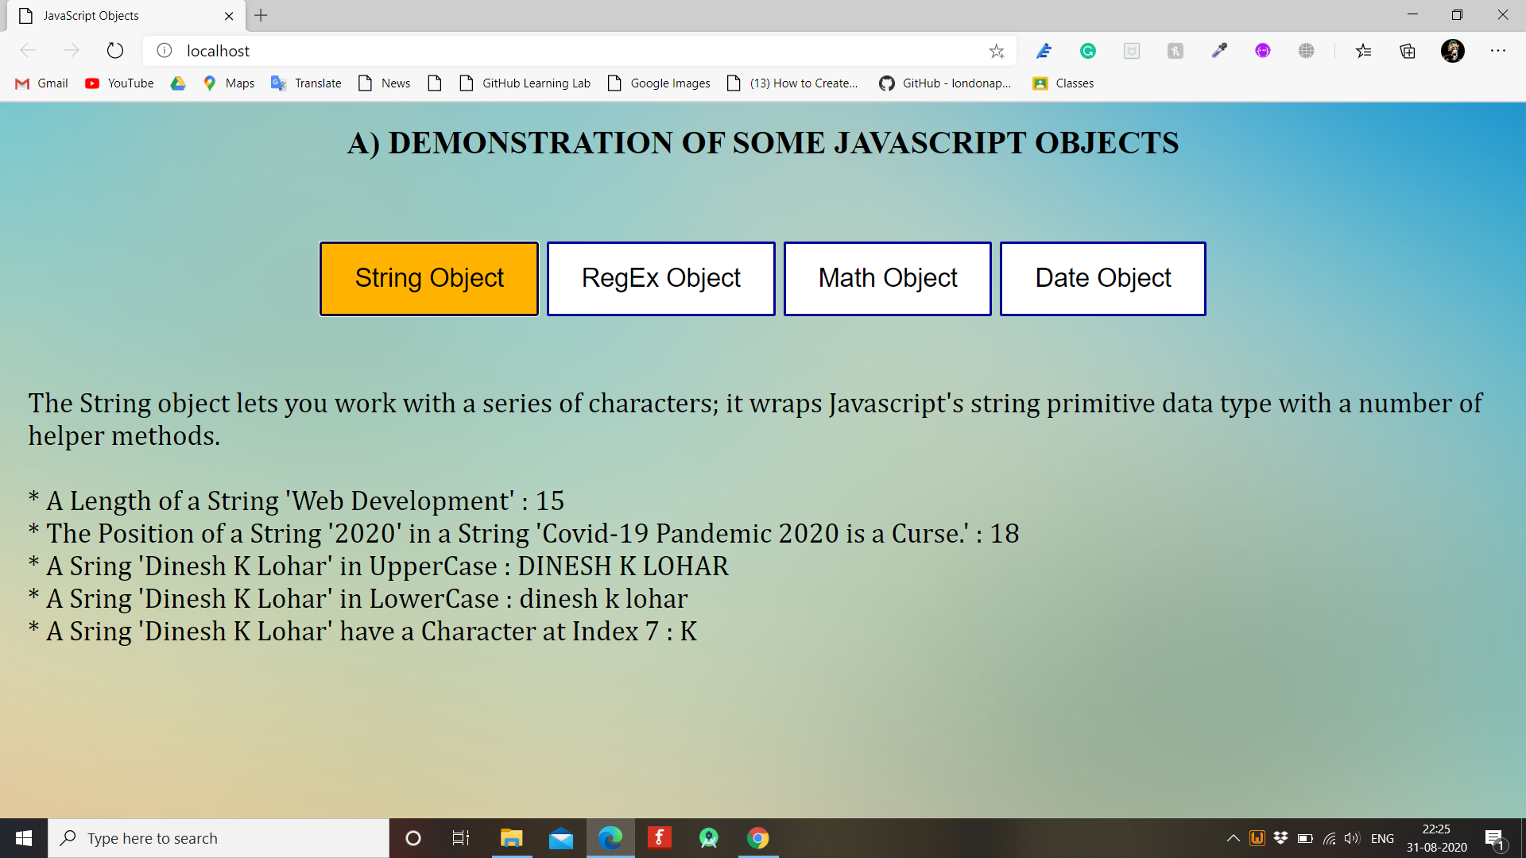

**RegExp Object**

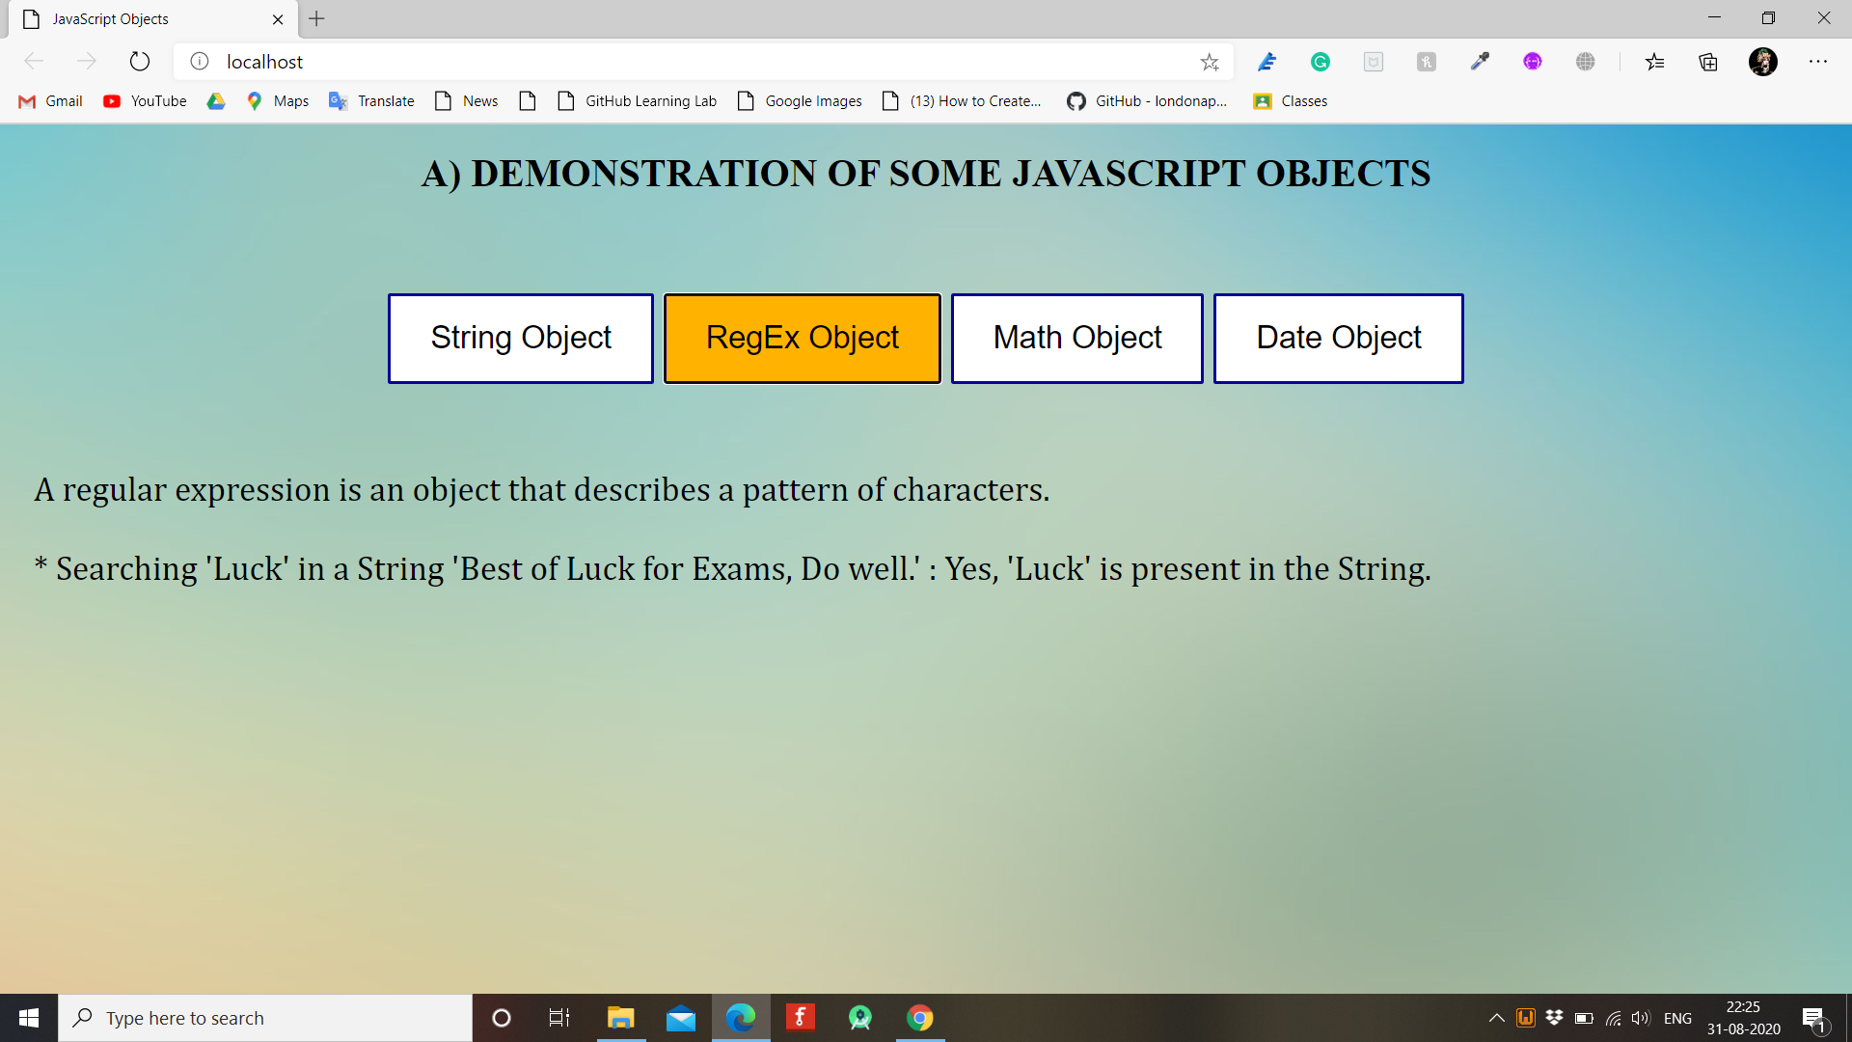

**Math Object**

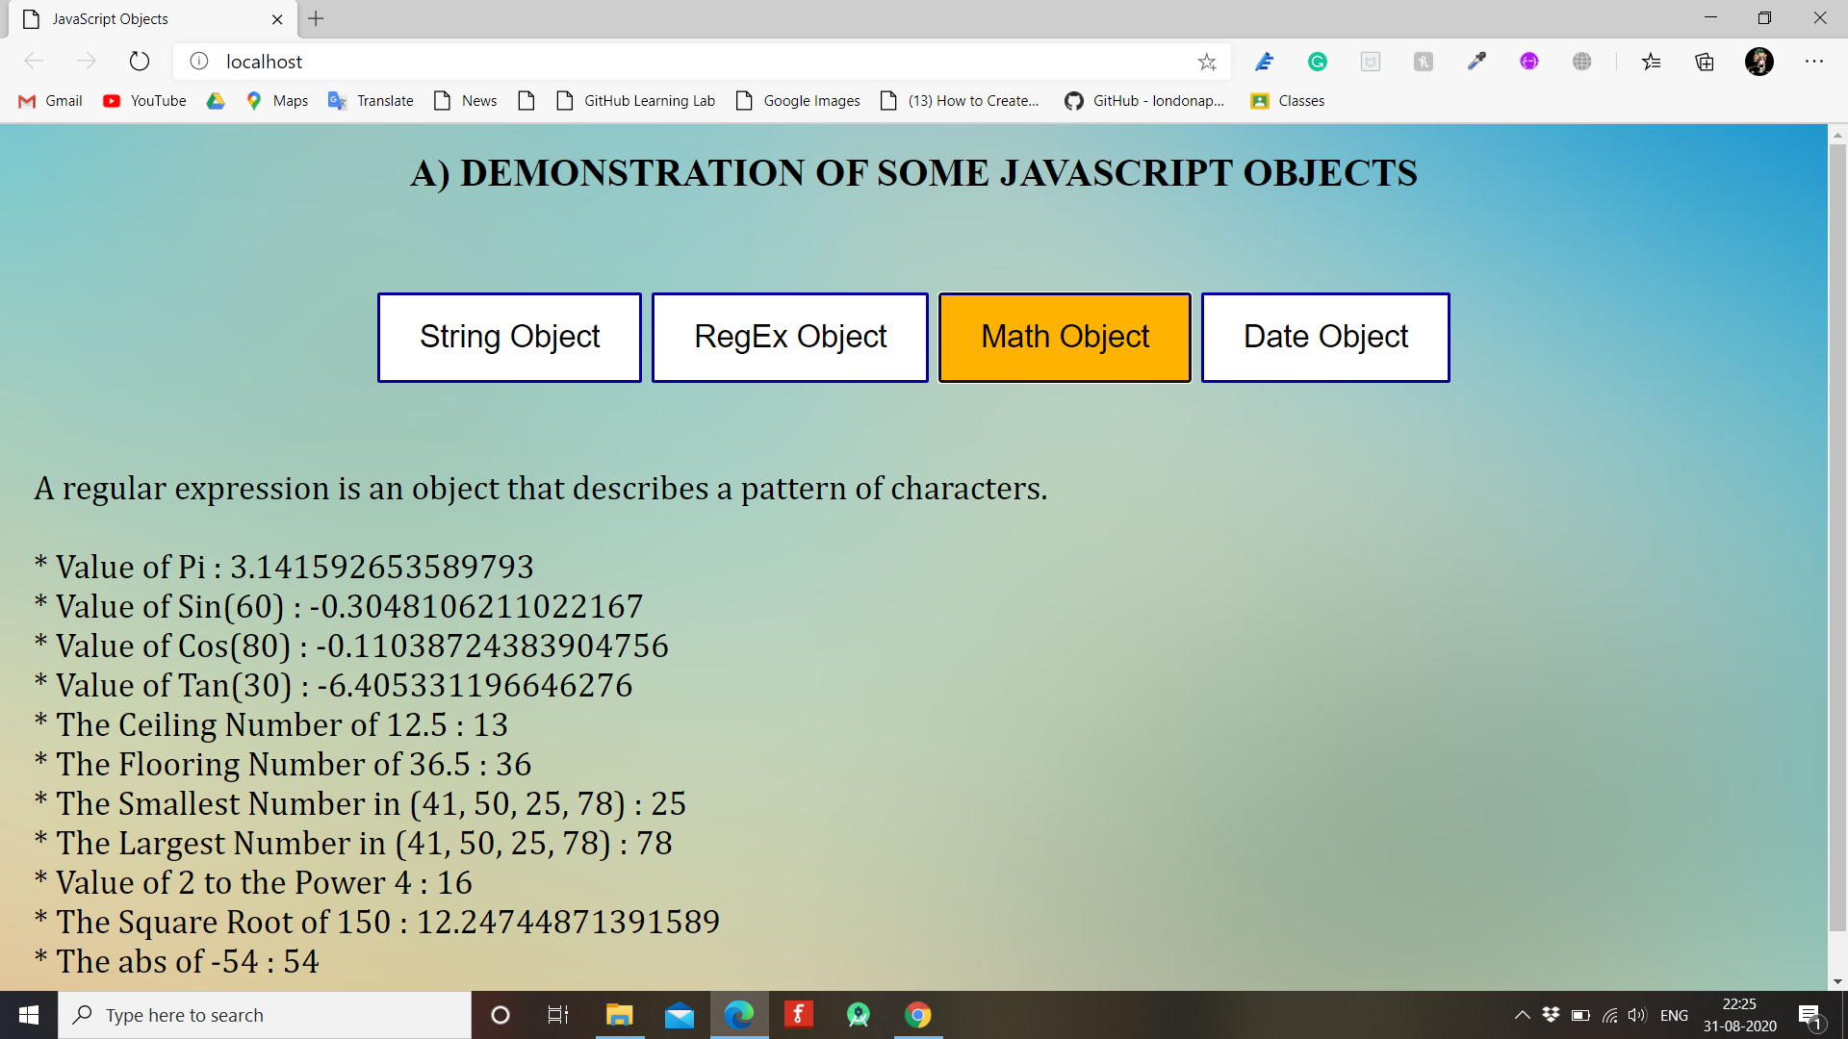

**Date Object**

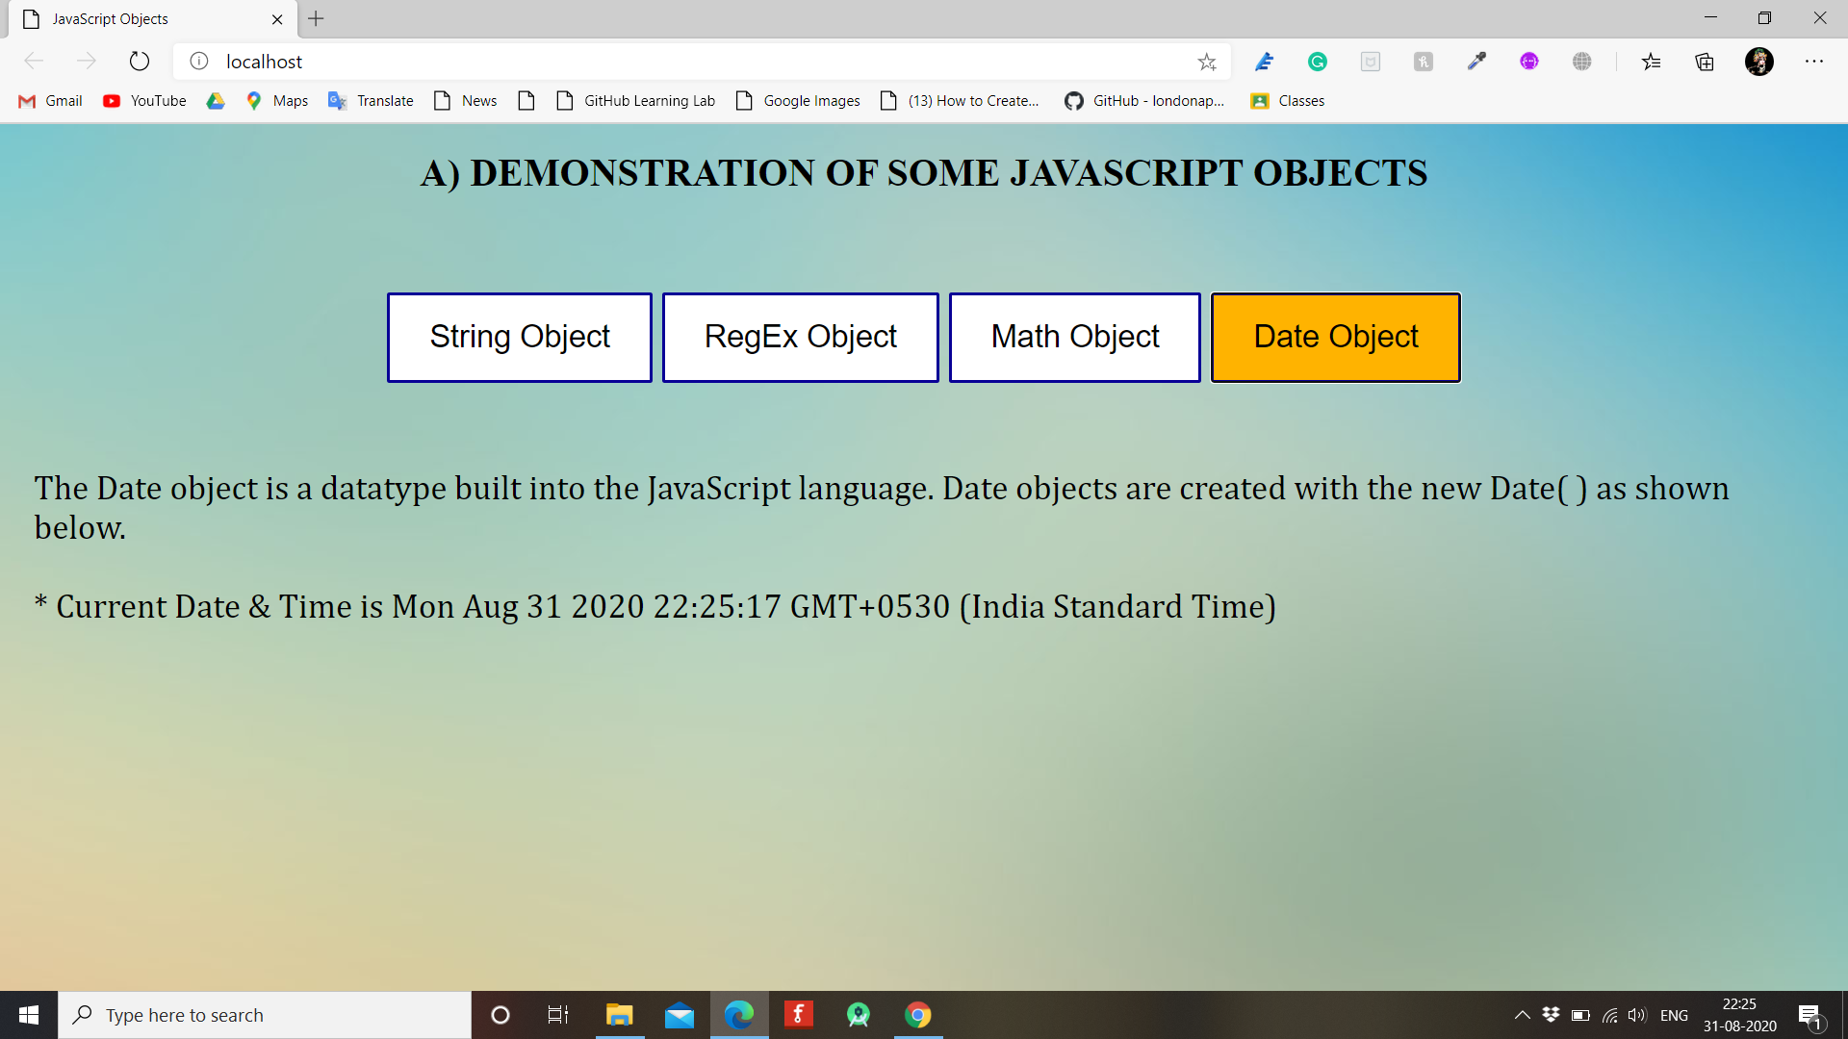

**B) Demonstrating different JavaScript Objects such as Window, Navigator, History, Location, Document.**

**SOURCE CODE:-**

<!--Dinesh K Lohar 2030-->

<!--B)Demonstrating different JavaScript Objects such as Window, History, Location, Document, Navigator.-->

<!DOCTYPE html>

<html>

<head>

<meta charset="utf-8">

<title>JavaScript Objects</title>

<style>

p {

font-size: 28px;

font-family: Cambria;

padding: 20px;

}

body {

background-image: url("bg1.jpg");

background-size: cover;

}

.button {

border: none;

color: white;

padding: 20px 32px;

text-align: center;

text-decoration: none;

display: inline-block;

font-size: 26px;

margin: 4px 2px;

transition-duration: 0.4s;

cursor: pointer;

}

.button1 {

background-color: white;

color: black;

border: 3px solid #080096;

}

.button1:hover {

background-color: #ffb300;

color: black;

}

</style>

<script type="text/javascript">

//Navigator Object

function navigator1() {

var x = " * Java Enabled: " + navigator.javaEnabled();

var browser = " * Browser Name: " + navigator.appName;

var browser_version = navigator.appVersion;

var version = " * Browser Version: " + parseFloat(browser_version);

var cookies = " * Navigator Cookies Enabled: " + navigator.cookieEnabled;

var out = x + "<br />" + browser + "<br />" + version + "<br />" + cookies;

document.getElementById("op").innerHTML = "The navigator object contains information about the browser.<br /><br />" + out;

}

//Location Object

function location1() {

var url = "The full URL of this page is: " + window.location.href;

var hostname1 = "Page hostname is: " + window.location.hostname;

var path = "Page path is: " + window.location.pathname;

var protocol1 = "The page protocol is: " + window.location.protocol;

var opt = url + "<br />" + hostname1 + "<br />" + path + "<br />" + protocol1;

document.getElementById("op").innerHTML = "The location object contains information about the current URL.<br /><br />" + opt;

}

</script>

</head>

<body>

<center>

<h1>B) DEMONSTRATION OF SOME JAVASCRIPT OBJECTS</h1>

<br><br><br>

<a href="window.html"><button class="button button1" type="button">Window Object</button></a>

<a href="history.html"><button class="button button1" type="button">History Object</button></a>

<button class="button button1" type="button" onclick="navigator1()">Navigator Object</button>

<button class="button button1" type="button" onclick="location1()">Location Object</button>

<a href="document.html"><button class="button button1" type="button">Document Object</button></a>

<br><br>

</center>

<p id="op">JavaScript is designed on a simple object-based paradigm. An object is a collection of properties, and a property is an association between a name (or key) and a value. A property's value can be a function, in which case the property is

known as a method. In addition to objects that are predefined in the browser, you can define your own objects. This chapter describes how to use objects, properties, functions, and methods, and how to create your own objects.</p>

</body>

</html>

**Code for Window Object**

<!--Dinesh K Lohar 2030-->

<!--B).1 Window-->

<!DOCTYPE html>

<html>

<head>

<meta charset="utf-8">

<title>JavaScript Objects</title>

<style>

div {

font-size: 28px;

font-family: Cambria;

padding: 20px;

}

body {

background-image: url("bg1.jpg");

background-size: cover;

}

.button {

border: none;

color: white;

padding: 20px 32px;

text-align: center;

text-decoration: none;

display: inline-block;

font-size: 26px;

margin: 4px 2px;

transition-duration: 0.4s;

cursor: pointer;

}

.button1 {

background-color: white;

color: black;

border: 3px solid #080096;

}

.button1:hover {

background-color: #ffb300;

color: black;

}

</style>

<script type="text/javascript">

var myWindow;

function openWin() {

myWindow = window.open("", "myWindow", "width=500, height=500");

}

function closeWin() {

if (myWindow) {

myWindow.close();

}

}

function checkWin() {

if (!myWindow) {

document.getElementById("msg").innerHTML = "Status of the Window : 'Window' has never been opened!";

} else {

if (myWindow.closed) {

document.getElementById("msg").innerHTML = "Status of the Window : 'Window' has been closed!";

} else {

document.getElementById("msg").innerHTML = "Status of the Window : 'Window' has not been closed!";

}

}

}

function colors() {

myWindow.document.bgColor="grey";

myWindow.document.fgColor="blue";

myWindow.focus();

}

function size1() {

var w = window.outerWidth;

var h = window.outerHeight;

document.getElementById("msg").innerHTML = "The Dimensions of the Browser Window is<br><br>Width: " + w +" pixels"+ "<br>Height: " + h + " pixels";

}

</script>

</head>

<body>

<center>

<h1>WINDOW OBJECT</h1>

<br><br><br>

<button class="button button1" onclick="openWin()">Open "Window"</button>

<button class="button button1" onclick="closeWin()">Close "Window"</button>

<button class="button button1" onclick="checkWin()">Has "Window" been closed?</button>

<button class="button button1" onclick="colors()">Change "Window" color</button>

<button class="button button1" onclick="size1()">Browser Window Size</button>

<br><br>

<div id="msg">The window object represents an open window in a browser.

If a document contain frames tags, the browser creates one window object for the HTML document, and one additional window object for each frame.</div>

</center>

</body>

</html>

**Code for History Object**

<!--Dinesh K Lohar 2030-->

<!--B).2 History.-->

<!DOCTYPE html>

<html>

<head>

<meta charset="utf-8">

<title>JavaScript Objects</title>

<style>

p {

font-size: 28px;

font-family: Cambria;

padding: 20px;

}

body {

background-image: url("bg1.jpg");

background-size: cover;

}

.button {

border: none;

color: white;

padding: 20px 32px;

text-align: center;

text-decoration: none;

display: inline-block;

font-size: 26px;

margin: 4px 2px;

transition-duration: 0.4s;

cursor: pointer;

}

.button1 {

background-color: white;

color: black;

border: 3px solid #080096;

}

.button1:hover {

background-color: #ffb300;

color: black;

}

</style>

<script type="text/javascript">

function frwd() {

window.history.forward();

}

function go() {

var ask = prompt("Enter a URL from History");

window.history.go(ask);

}

function bk() {

window.history.back();

}

function len() {

var x = history.length;

document.getElementById("op").innerHTML = " * Number of URLS in History List: " + x;

}

</script>

</head>

<body>

<center>

<h1>HISTORY OBJECT</h1>

<br><br><br>

<button class="button button1" type="button" onclick="bk()">BACK</button>

<button class="button button1" type="button" onclick="go()">GO</button>

<button class="button button1" type="button" onclick="frwd()">FORWARD</button>

<button class="button button1" type="button" onclick="len()">HISTORY</button>

<br><br>

</center>

<p id="op">The history object contains the URLs visited by the user (within a browser window).

The history object is part of the window object and is accessed through the window.history property.</p>

</body>

</html>

**Code for Document Object**

<!--Dinesh K Lohar 2030-->

<!--B).5 Document-->

<!DOCTYPE html>

<html>

<head>

<meta charset="utf-8">

<title>JavaScript Objects</title>

<style>

div {

font-size: 28px;

font-family: Cambria;

padding: 20px;

}

body {

background-image: url("bg1.jpg");

background-size: cover;

}

.button {

border: none;

color: white;

padding: 20px 32px;

text-align: center;

text-decoration: none;

display: inline-block;

font-size: 26px;

margin: 4px 2px;

transition-duration: 0.4s;

cursor: pointer;

}

.button1 {

background-color: white;

color: black;

border: 3px solid #080096;

}

.button1:hover {

background-color: #ffb300;

color: black;

}

</style>

<script type="text/javascript">

var myWindow;

function dom() {

var x = document.domain;

document.getElementById("msg").innerHTML = "The Domain of this document: <br />" + x;

}

function inpEn() {

var x = document.inputEncoding;

document.getElementById("msg").innerHTML = "This document is encoded by " + x;

}

function mod() {

var x = document.documentMode;

document.getElementById("msg").innerHTML = "This document is displayed in IE" + x + " mode";

}

function laMod() {

var x = document.lastModified;

document.getElementById("msg").innerHTML = "This document is Last Modified at " + x;

}

</script>

</head>

<body>

<center>

<h1>DOCUMENT OBJECT</h1>

<br><br><br>

<button class="button button1" onclick="dom()">Domain</button>

<button class="button button1" onclick="inpEn()">Input Encoding</button>

<button class="button button1" onclick="mod()">Mode</button>

<button class="button button1" onclick="laMod()">Last Modified</button>

<br><br>

<div id="msg"> A Document object represents the HTML document that is displayed in that window. The Document object has various properties that refer to other objects which allow access to and modification of document content.</div>

</center>

</body>

</html>

**OUTPUT:-**

**HOME PAGE**

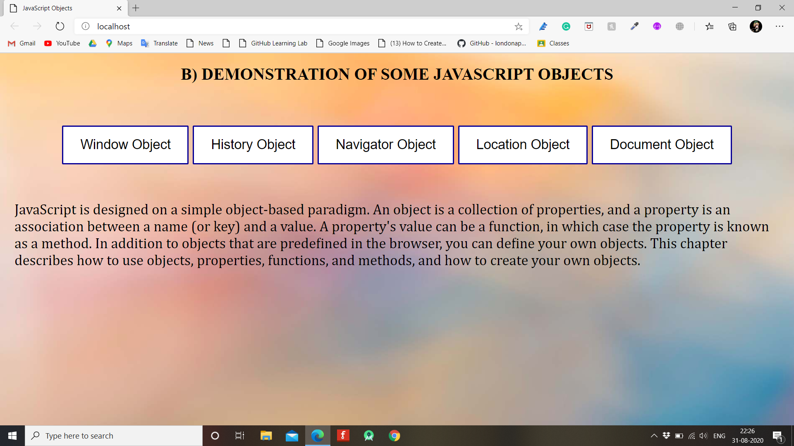

1. **WINDOW OBJECT**

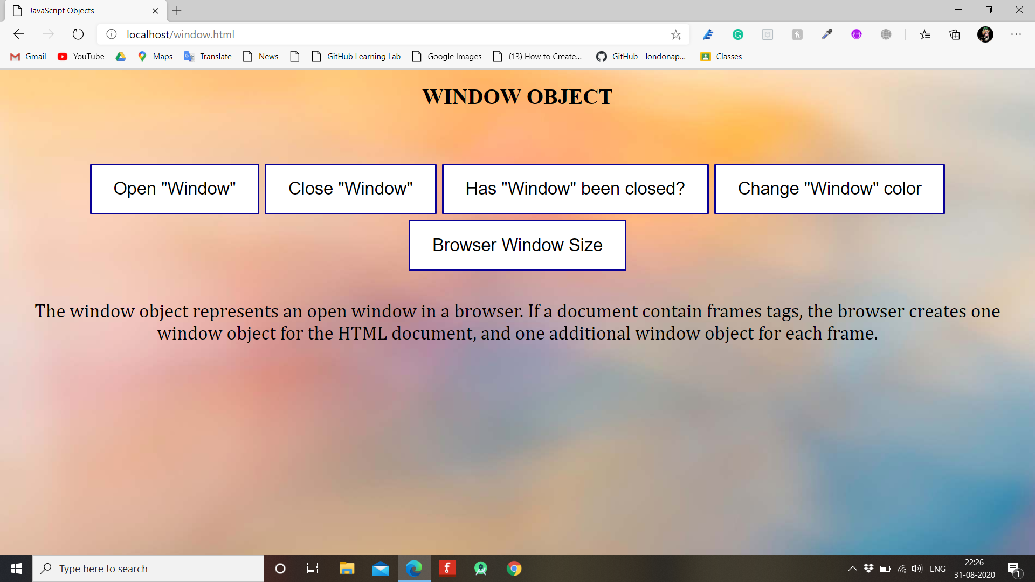

**Open Window**

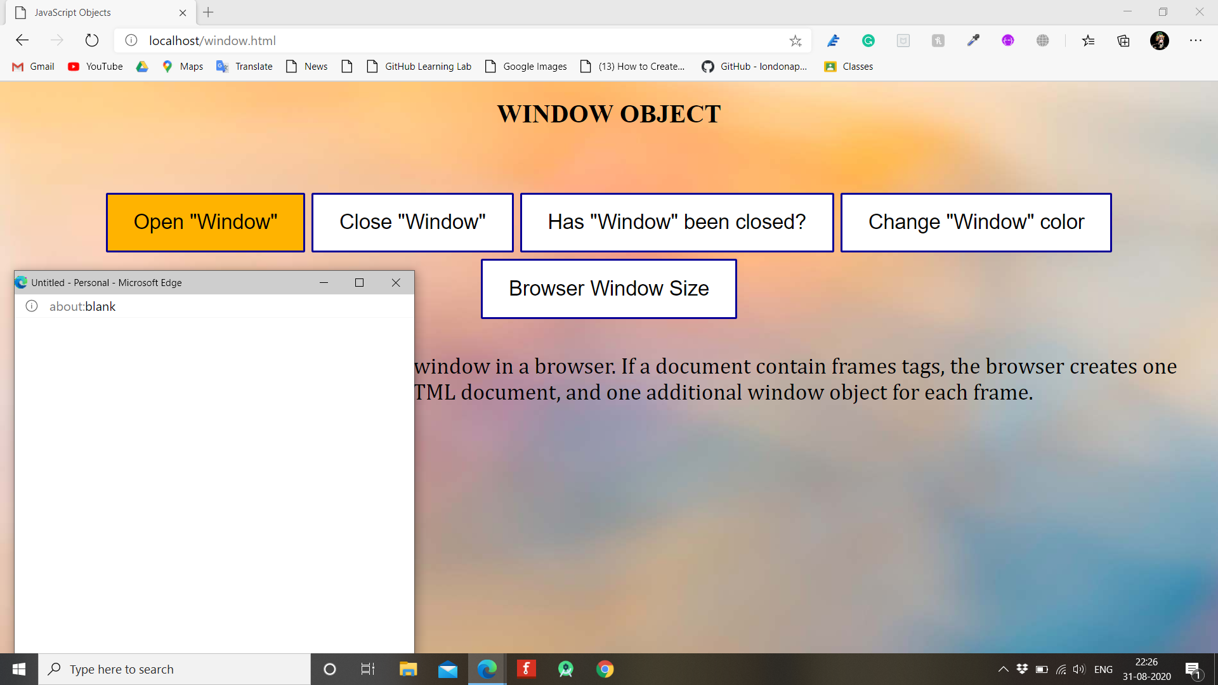

**Change Window Color**

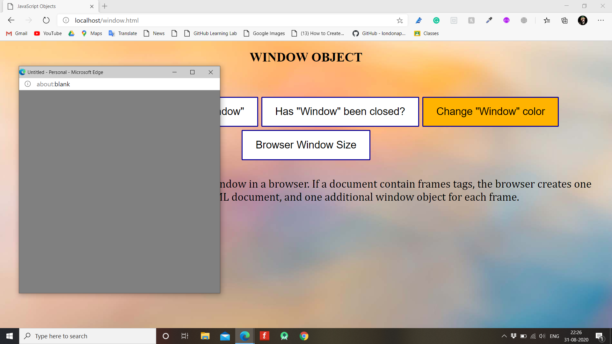

**Has Window been closed?**

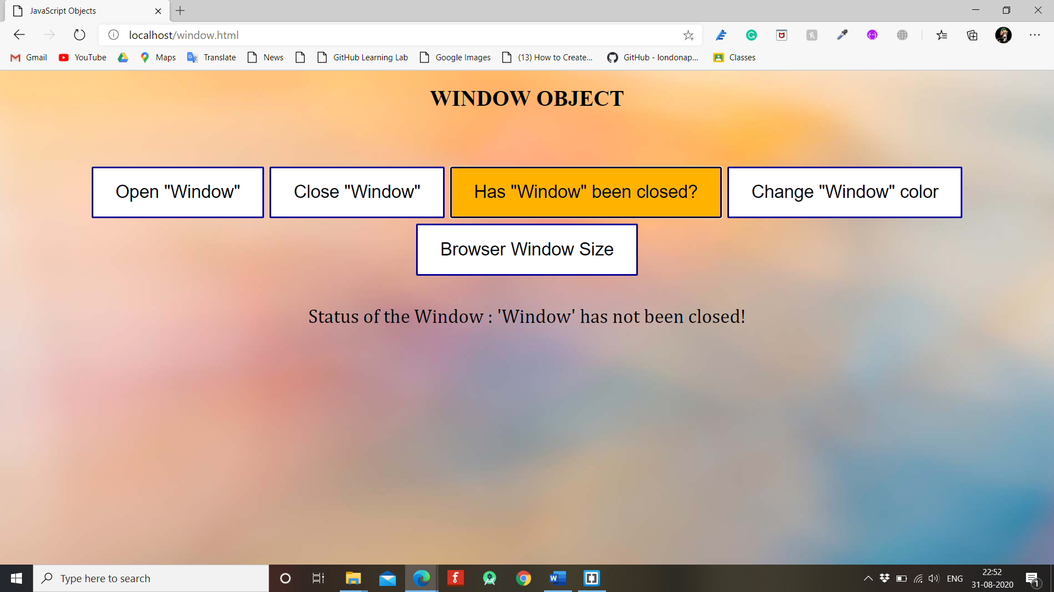

**Close Window**

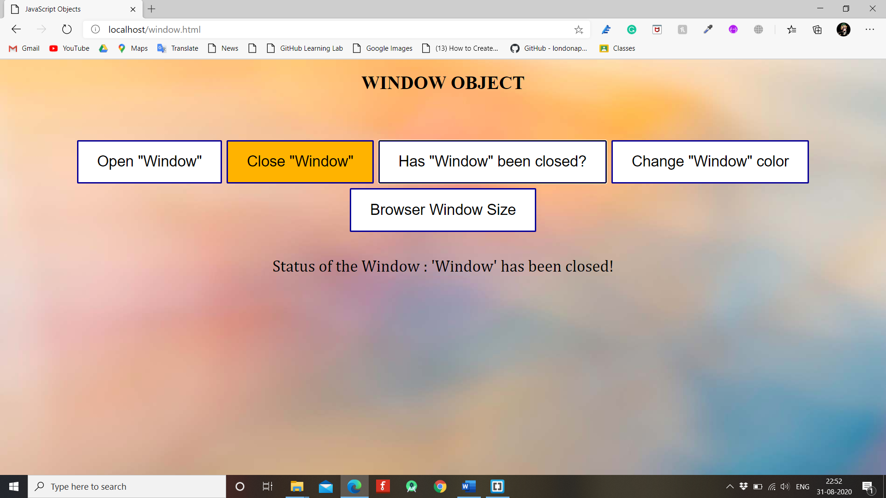

**Browser Size**

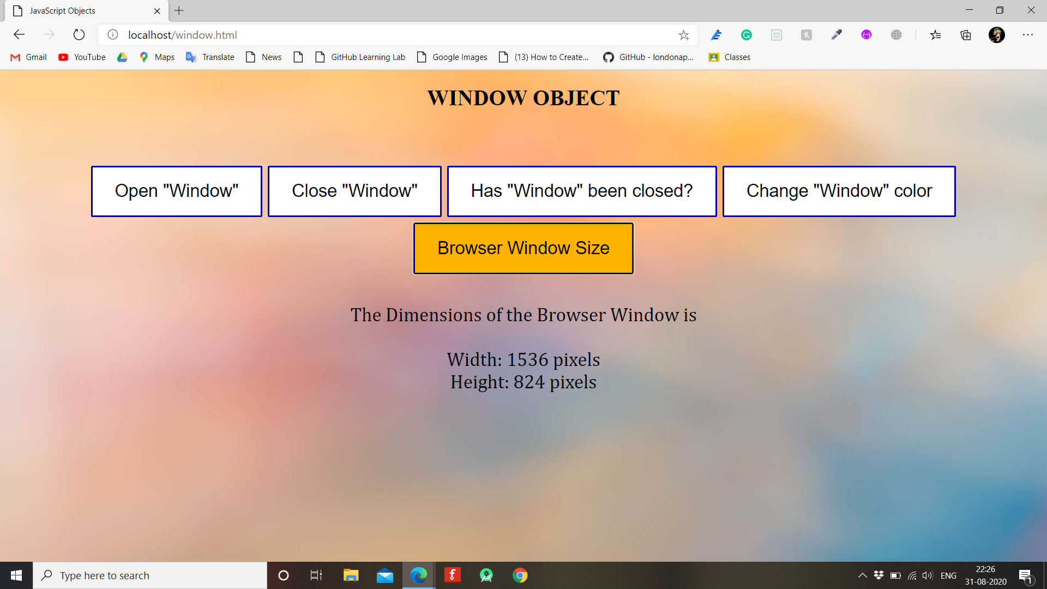

1. **HISTORY OBJECT**

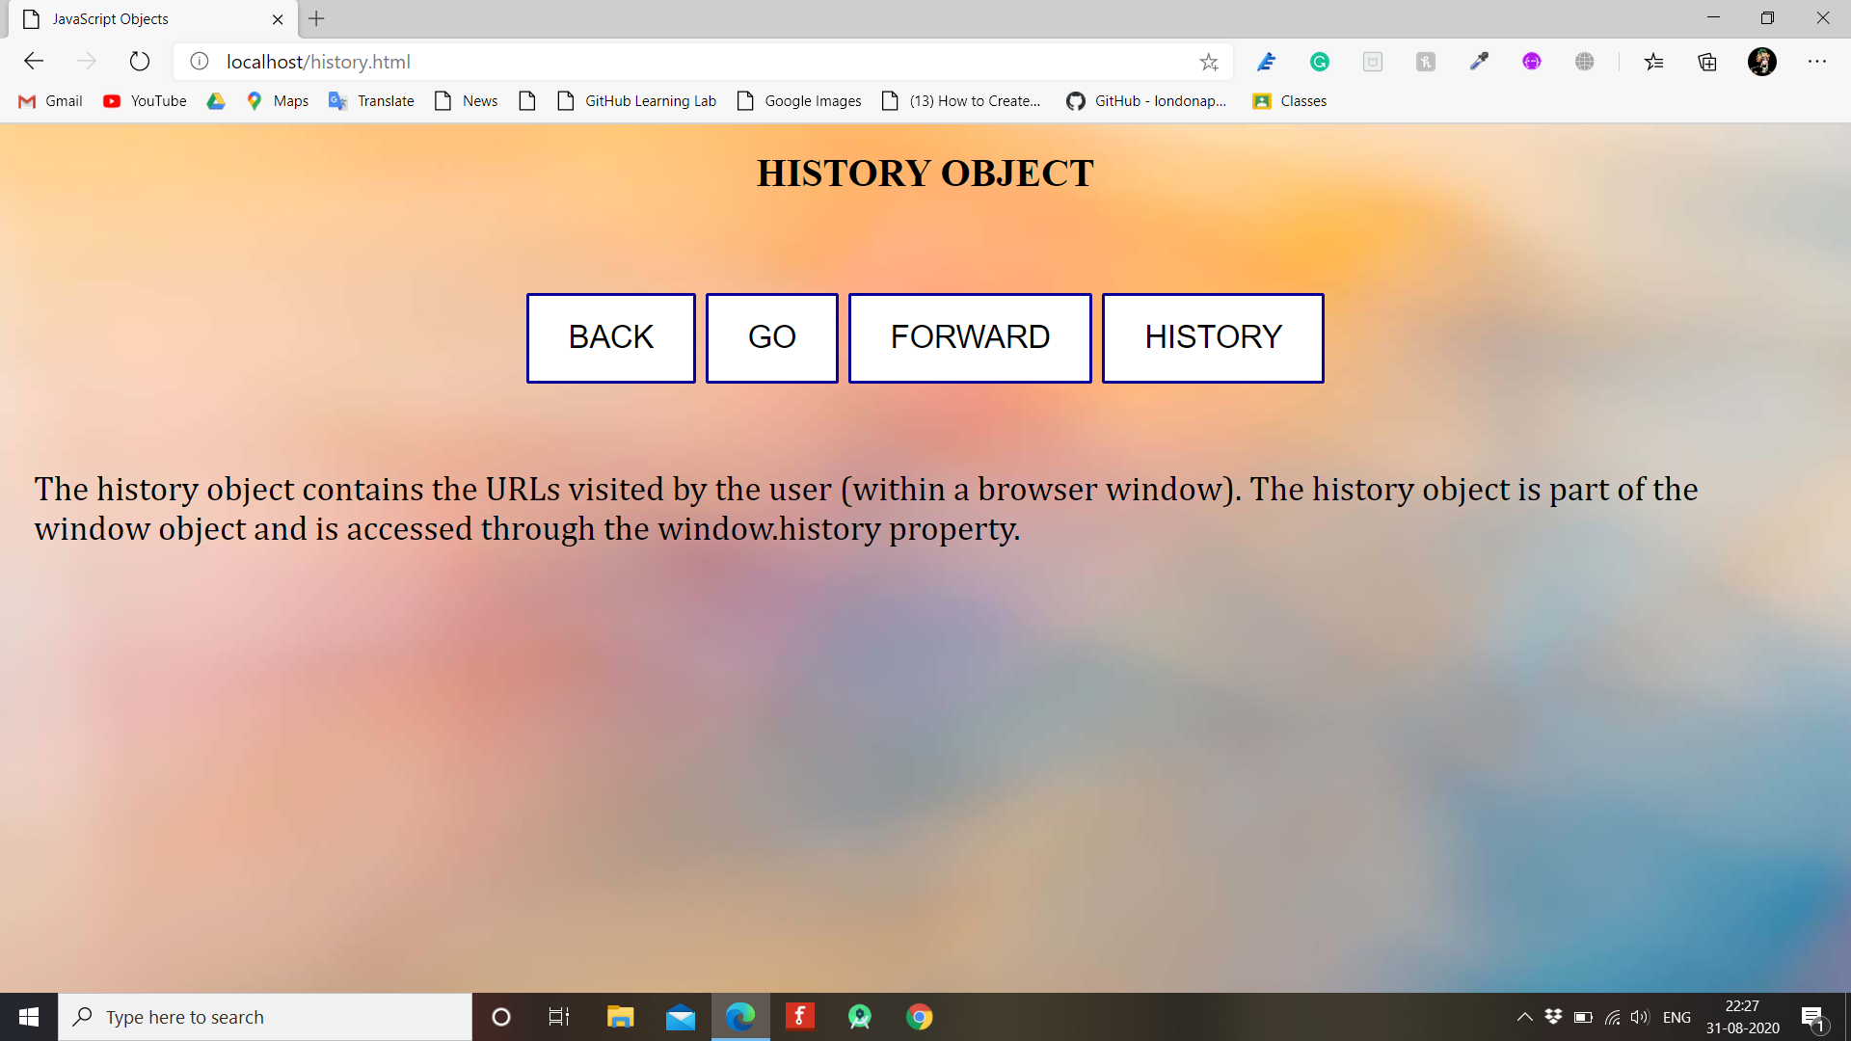

**History**

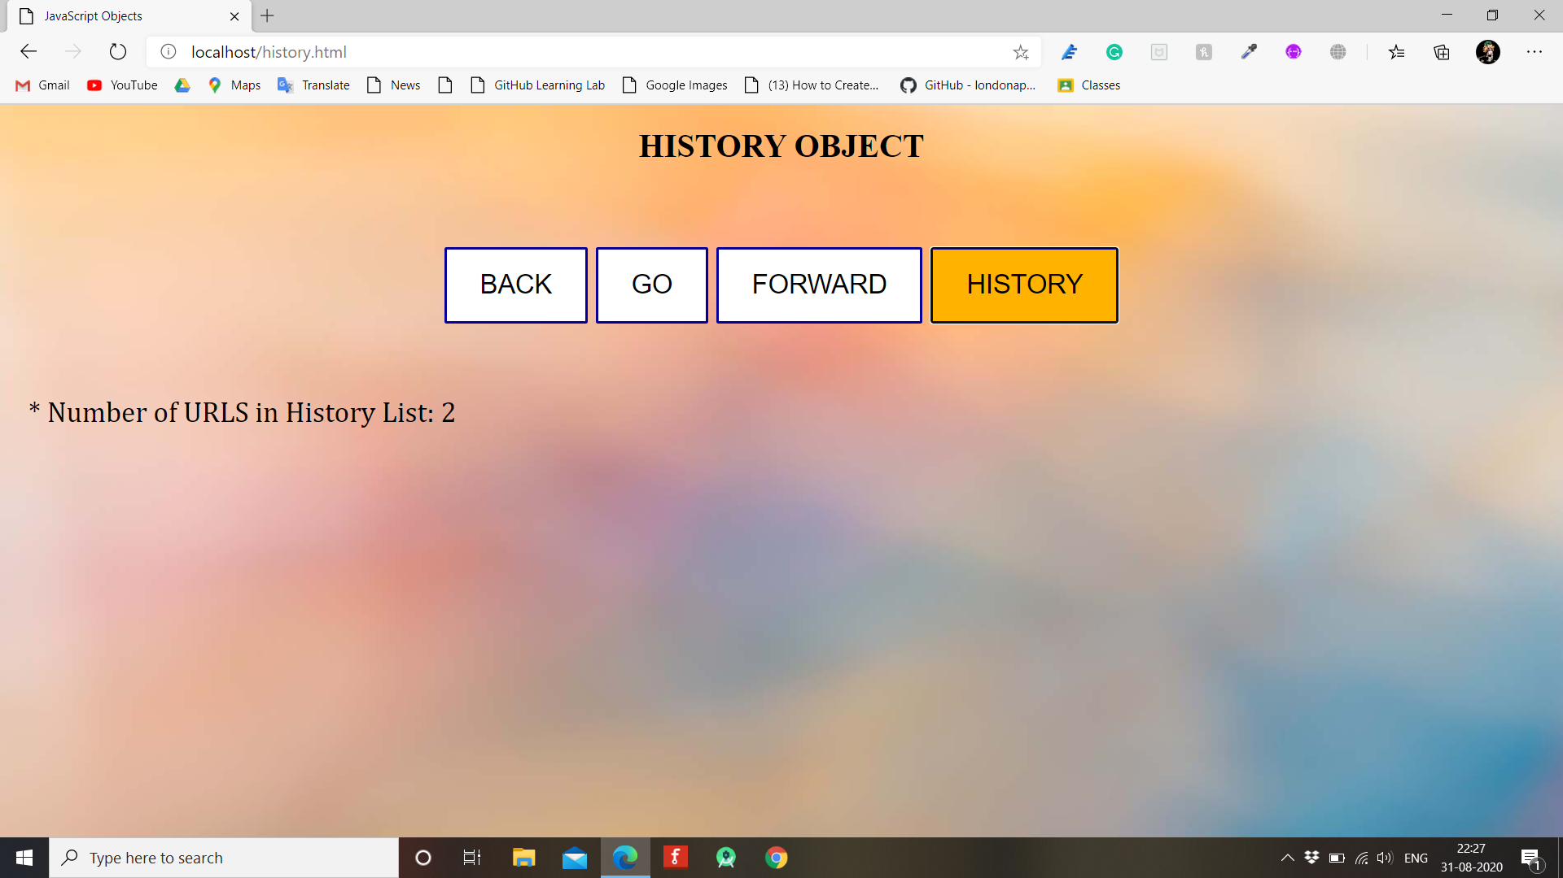

1. **NAVIGATOR OBJECT**

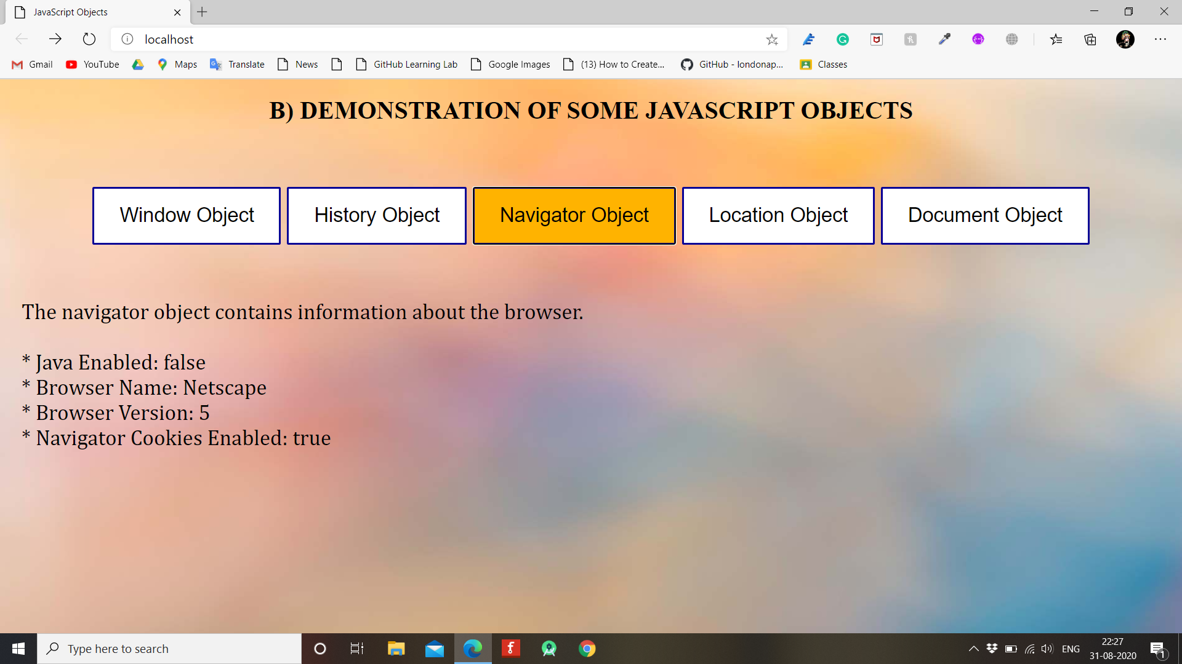

1. **LOCATION OBJECT**

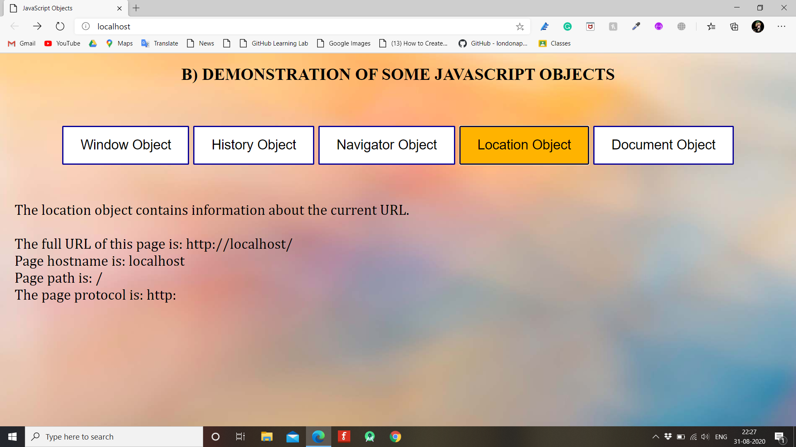

1. **DOCUMENT OBJECT**

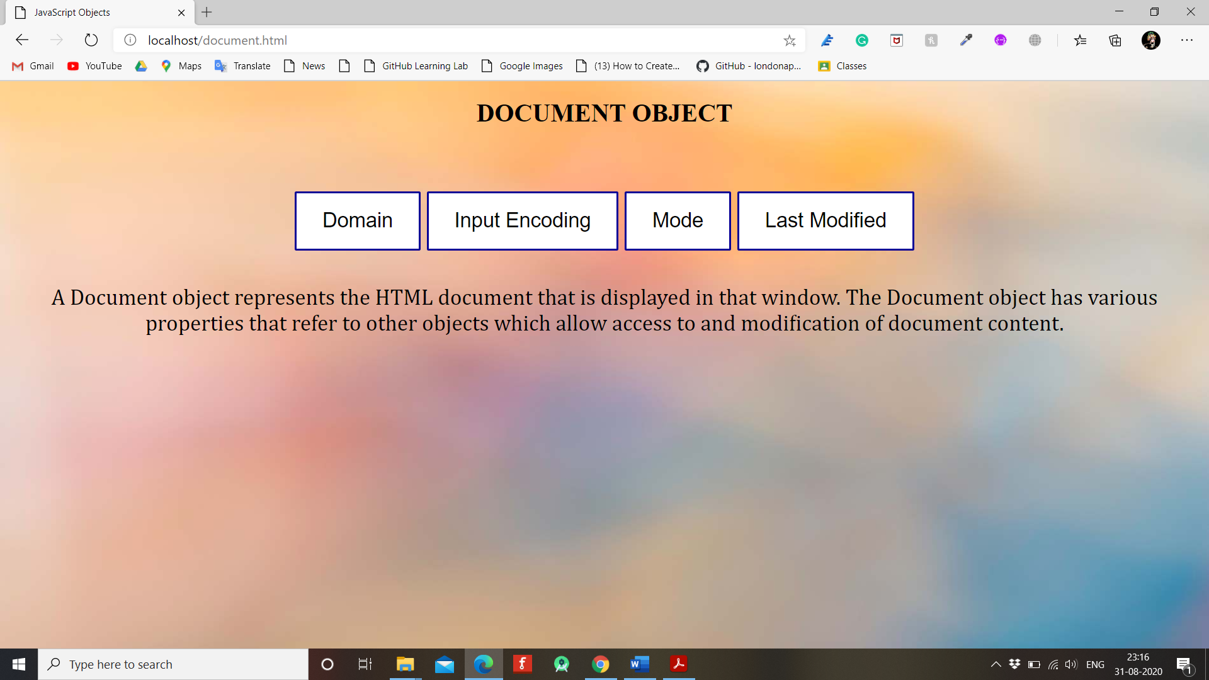

**Domain**

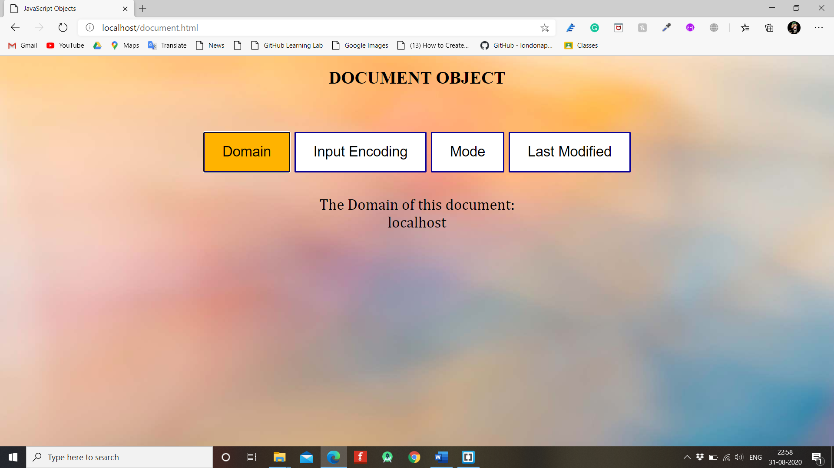

**Input Encoding**

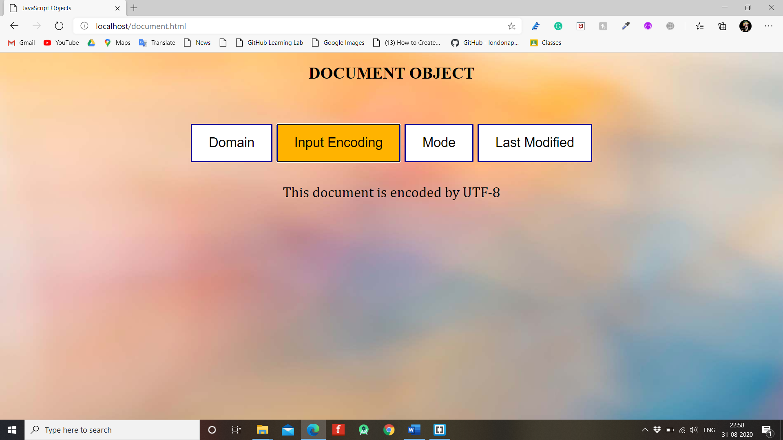

**Mode**

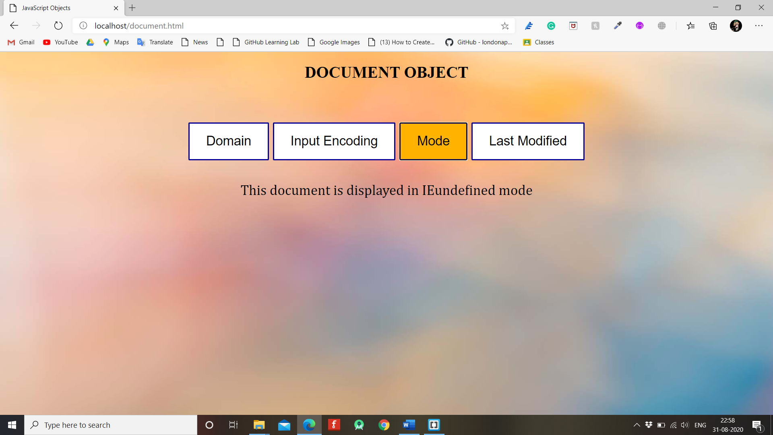

**Last Modified**

